|  |  |  |  |  |  |
| --- | --- | --- | --- | --- | --- |
|  | **MARK (NOT)** | **2016-2017 EDUCATIONAL PERIOD** | | | **DATE (TARİH)** |
|  |  | **DADAY IMAM HATIP SECONDARY SCHOOL** | | | **...../ ......./ 2017** |
|  | **ENGLISH LESSON** | **2ND TERM** | **1 ST EXAM** |
|  | **QUESTIONS** | **FOR GRADE 7TH** | | **­­­­­­­­­­­­________________** |
|  | **NAME (AD)** |  | | |
|  | **SURNAME (SOYAD)** |  | | | **MEHMET** |
|  | **NUMBER (NO)** |  | | | **DEGERLI** |

some - any

**2X5=10**

**1)** There is ……….............……...…… water in the bootle.

**2)** There is …………............…..…...….. milk in the glass.

**3)** There are………..........…….…...….. apples on the table.

**4)** There are …….....…...………...….. bananas in the basket.

**5)** There are ……......………………… teachers in the school.

a few - a little

**1.2X5=10**

1. There is ………...............…… milk in the bottle.
2. Is there ……….................... money in your pocket?
3. Is there ………........................milk in the glass?
4. There are ……......................students in the class.
5. There aren’t …...........……………..doctors in the hospital.

How much - How many

**2.2X5=10**

1. …............……….............…….. mechanics are there in the factory?
2. …............…….....…………..…… pencils are there in the pencil box?
3. …..............………………..……….. cars are there at the car-park?
4. …...............……………....……… ice cream is there in the fridge?
5. …...............……………...... money is there in your pocket?

**3.MATCH THEM 2x5=10**

____1.GET A. THE SUITABLE MUSIC

____2.SEND B. PERMISSION

____3.ARRANGE C. THE PARTY ROOM

____4.LAY D. THE INVITTIONS

____5.DECORATE E. THE TABLES

**4.HOW TO THROW A BIRTHDAY PARTY? PUT INTO ORDER 2x6=12**

**____e.Decorate the part room.**

**____g.If you get the permission,make a guest list.**

**____d.Have a birthday cake.**

**____c.Arrange the suitable music for the party.**

**____f.Then prepare your party invitation cards and send them to the guests.**

**_1_h.Ask your parent’s permisson to host a birtday party**

**____i.Prepare other food and beverages.**

**5. FILL IN THE BLANKS WITH-IN-AT-AT 2x4=8**

**Hi Mehmet,**

**It’s my birthday next Sunday.It is.........April 2ND.I’m having a party ......... our garden.It starts ........07.00 p.m. and finishes .........09.00 p.m..I will be very happy if you can come to my party.We will decorate the garden with the cloured balloons.There are a big party cake,music and a lots drinks.There is also DJ.So there is a great music and dancing.**

**Please let me know if you can come.**

**Hope to see you on Sunday.**

**6.MATCH THEM 2x5=10**

 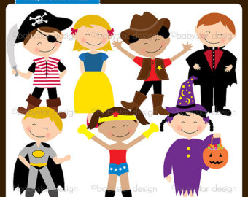 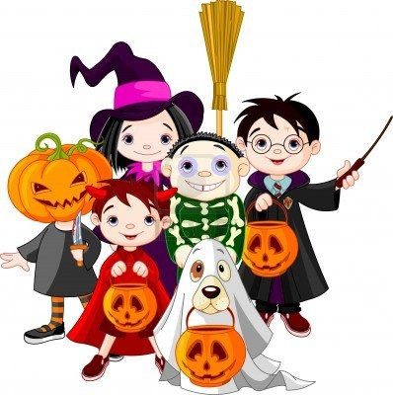

**A.Birthday party B.Fancy Dress Party C.Wedding Party D.Hallowen Party E.Pyjamas Party**

**7.FILL IN THE BLANKS WITH THESE WORDS 2x5=10**

**BLACK CAT - BREAKING – WALKING – HANGING – FINDING -**

**1……..............……….a mirror.**

**2……................………under a ladder.**

**3…….............………..a horseshoe above the door.**

**4……..............………….a four-leaf clover.**

**5…….................………..crossing your path.**

**8.MATCH THE SENTENCES WTH THE PICTURES 2X5=10**

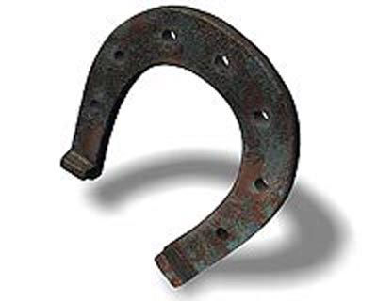 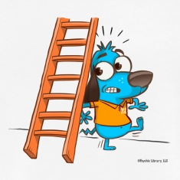

**CLASSIFY THESE SENTENCES IN TWO GROUPS (2X5=10)**

|  |  |
| --- | --- |
| **Bad Luck Superstitions** | **Good Luck Superstitions** |
| 1. **…….............………...........................**  2. **…….................................................**  3. **…….................................................**  4.  5. | 1. **…............................................................**  2. **…….........................................................**  3.  4.  5. |

**20.03.2017**

**UYGUNDUR**

**AYDIN DEMİRAL**

**OKUL MÜDÜRÜ**

**CEVAP ANAHTARI**

|  |  |  |  |  |  |
| --- | --- | --- | --- | --- | --- |
|  | **MARK (NOT)** | **2016-2017 EDUCATIONAL PERIOD** | | | **DATE (TARİH)** |
|  |  | **DADAY IMAM HATIP SECONDARY SCHOOL** | | | **...../ ......./ 2017** |
|  | **ENGLISH LESSON** | **2ND TERM** | **1 ST EXAM** |
|  | **QUESTIONS** | **FOR GRADE 7TH** | | **­­­­­­­­­­­­________________** |
|  | **NAME (AD)** |  | | |
|  | **SURNAME (SOYAD)** |  | | | **MEHMET** |
|  | **NUMBER (NO)** |  | | | **DEGERLI** |

some - any

**2X5=10**

**1)** There is ………..a little……...…… water in the bootle.

**2)** There is …………a little…..…...….. milk in the glass.

**3)** There are………a few…….…...….. apples on the table.

**4)** There are ……a few…………...….. bananas in the basket.

**5)** There are ……a few………………… teachers in the school.

a few - a little

**1.2X5=10**

1. There is ………some.......…… milk in the bottle.
2. Is there ………any......………. money in your pocket?
3. Is there ………any..…………………milk in the glass?
4. There are ……some……………..students in the class.
5. There aren’t …any……………..doctors in the hospital.

How much - How many

**2.2X5=10**

1. …How many…………….. mechanics are there in the factory?
2. …How many………………..…… pencils are there in the pencil box?
3. …How many………………..……….. cars are there at the car-park?
4. …How much……………....……… ice cream is there in the fridge?
5. …How much……………...... money is there in your pocket?

**3.MATCH THEM 2x5=10**

Get permisson

Send the invitation

Lay the tables

Decorate the party room

Arrange the suitable music

_B__1.GET A. THE SUITABLE MUSIC

_D__2.SEND B. PERMISSION

_A_3. ARRANGE C. THE PARTY ROOM

_E_4.LAY D. THE INVITTIONS

_C_5.DECORATE E. THE TABLES

**4.HOW TO THROW A BIRTHDAY PARTY? PUT INTO ORDER 2x6=12**

**_4_e.Decorate the party room.**

**_2_g.If you get the permission,make a guest list.**

**_5_d.Have a birthday cake.**

**_7_c.Arrange the suitable music for the party.**

**_3_f.Then prepare your party invitation cards and send them to the guests.**

**_1_h.Ask your parent’s permisson to host a birtday party**

**_6_i.Prepare other food and beverages.**

**5. FILL IN THE BLANKS WITH-IN-AT-AT-IN 2x4=8**

**Hi Mehmet,**

**It’s my birthday next Sunday.It is..in..April 2ND.I’m having a party ..in... our garden.It starts ...at..07.00 p.m. and finishes ..at...09.00 p.m..I will be very happy if you can come to my party.We will decorate the garden with the cloured balloons.There are a big party cake,music and a lots drinks.There is also DJ.So there is a great music and dancing.**

**Please let me know if you can come.**

**Hope to see you on Sunday.**

**6.MATCH THEM 2x5=10**

  

E

C

D

A

B

**A.Birthday party B.Fancy Dress Party C.Wedding Party D.Hallowen Party E.Pyjamas Party**

**7.FILL IN THE BLANKS WITH THESE WORDS 2x5=10**

**BLACK CAT - BREAKING – WALKING – HANGING – FINDING -**

**1……Breaking……….a mirror.**

**2……Walking..………under a ladder.**

**3……Hanging………..a horseshoe above the door.**

**4……Finding………….a four-leaf clover.**

**5……Black cat………..crossing your path.**

**8.MATCH THE SENTENCES WTH THE PICTURES 2X5=10**

 

3

2

1

4

5

**9.CLASSIFY THESE SENTENCES IN TWO GROUPS (2X5=10)**

|  |  |
| --- | --- |
| **Bad Luck Superstitions** | **Good Luck Superstitions** |
| 1. **……Breaking……….a mirror.**  2. **……Walking..………under a ladder.**  3. **……Black cat…..crossing your path.**  4.  5. | 1. **…Hanging.a horseshoe above the door.**  2. **……Finding…….a four-leaf clover.**  3.  4.  5. |

**20.03.2017**

**UYGUNDUR**

**AYDIN DEMİRAL**

**OKUL MÜDÜRÜ**