|  |  |  |  |  |
| --- | --- | --- | --- | --- |
| **MARK (NOT)** | **2015-2016 EDUCATIONAL PERIOD** | | | **DATE (TARİH)** |
|  | **DADAY IMAM HATIP SECONDARY SCHOOL** | | | **…../……./ 201…..** |
| **ENGLISH LESSON** | **1ST TERM** | **3 RD EXAM** |
| **QUESTIONS** | **FOR GRADE 7TH** | | **…………..** |
| **NAME (AD)** |  | | |
| **SURNAME (SOYAD)** | **CEVAP ANAHTARI** | | | **MEHMET** |
| **NUMBER (NO)** |  | | | **DEGERLI** |

**SECTION 1)**CATOGARIZE THE ANIMALS ONLY WRITE 10 ANIMALS INTO GROUPS (GRUPLARA YALNIZ 10 TANE HAYVAN İSMİ YAZALIM.) 2X10=20

|  |
| --- |
| **Fly - Elephant - Lion - Bee- Parrot - Whale - Crocodile - Parakeet - Tiger - Dolphin - Mammoth- Butterfly - Vulture – Bear - Ant - Shark - Eagle - Snake - Panda -Lizard-Koala- Dodo - Dinosaur – Moa -Turtle** |

|  |  |  |  |  |  |  |
| --- | --- | --- | --- | --- | --- | --- |
| **EXTINCT** | **WILD ANIMLAS** | **BIRDS** | **INSECTS** | **REPTILES** | **ENDANGERED ANIMAS** | **SEA ANIMALS** |
| **MAMMOTH** | **ELEPHANT** | **PARAKEET** | **ANT** | **CROCODILE** | **PANDA** | **WHALE** |
| **DINOSAUR** | **LION** | **EAGLE** | **BUTTERFLY** | **SNAKE** | **KOALA** | **DOLPHIN** |
| **MOA** | **TIGER** | **VULTURE** | **BEE** | **TURTLE** | **VULTURE** | **SHARK** |
| **DODO** | **BEAR** | **PARROT** | **FLY** |  |  |  |
|  |  |  |  |  |  |  |
|  |  |  |  |  |  |  |

**SECTION 2) Hayvanları tanımlarıyla eşleştiriniz. 2x5=10**

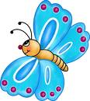

2

3

1

5

4

1. It is an insect.It has got wings.It lives on land.
2. It is a bird.It has got feathers and beak.It lives on land and in the trees.
3. It is a reptile.It has got sharp teeth.It lives both in water and land.
4. It is a mammal.It has got fins.It lives in water.
5. It is a mammal.It has got trunk.It lives on land

**SECTION 3) Hayvanların vücudunun bölümlerini yazın. (10 points)**



beak

fin

horns

wing

fur



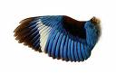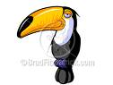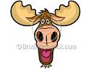

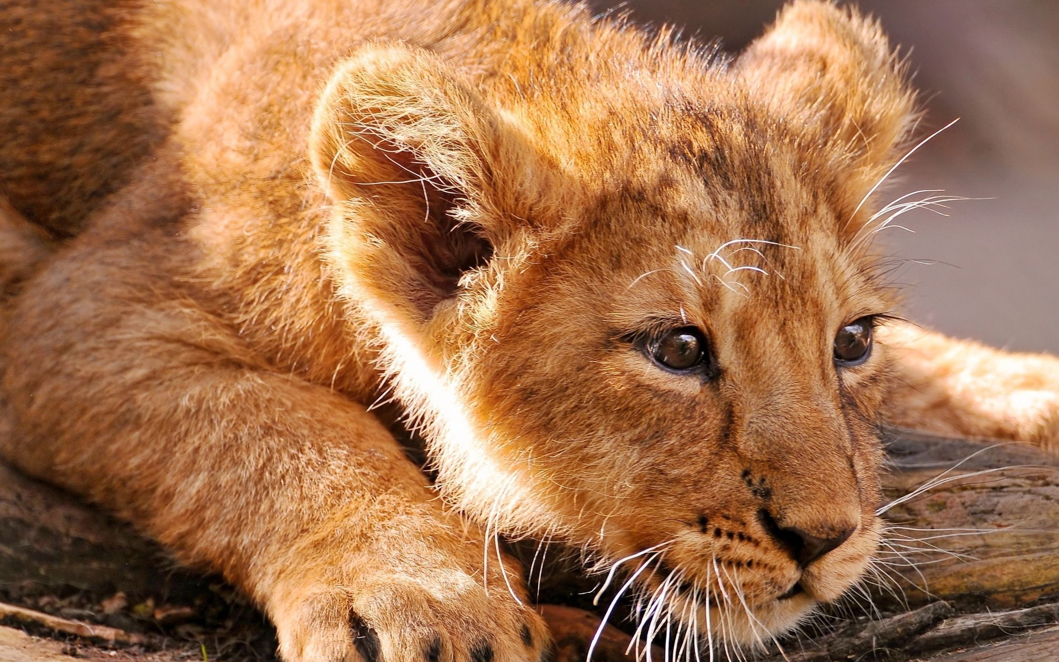

FIN FUR WING HORNS BEAK

**SECTION 4)** CATOGARIZE THE SPORTS( ONLY WRITE 10 SPORTS INTO THEVGROUPS (GRUPLARA YALNIZ 10 TANE SPOR İSMİ YAZALIM.) 2X10=20

|  |  |  |  |
| --- | --- | --- | --- |
| **Table tennis Football Athletics Basketball Volleyball Wind surfing**  **Gymnastics Baseball İce-skating Golf Archery**  **Roller-blading Rugby Swimming Cycling Horse riding Dancing** | | | |
| **Skating** | **Climbing** | **Climbing** |  |
|  | **Rugby** | **İce-skating** |  |
|  | **Scuba-diving** | **Swimming** |  |
|  | **Sailing** | **Scuba-diving** |  |
|  | **Skiing** | **Sailing** |  |
|  | **Parachuting** | **Dancing** |  |
|  | **Snowboarding** | **Skating** |  |
|  |  | **Skiing** |  |
|  |  | **Parachuting** |  |
|  |  | **Snowboarding** |  |

|  |  |  |  |
| --- | --- | --- | --- |
| Indoors  (İçerdeki) | Outdoors  (Dışardaki) | Individual sports/activities  (Kişisel sporlar/Aktiviteler) | Team sports  (Takım Sporları) |
| **TABLE TENNIS** | **FOOTBALL** | **ATHLETICS** | **FOOTBALL** |
| **WOLLEYBALL** | **HORSE RIDING** | **ARCHERY** | **VOLLEYBALL** |
| **ICE-SKATING** | **CYCLING** | **SWIMMING** | **BASEBALL** |
| **GYMNASTICS** | **WIND SURFING** | **ICE-SKATING** | **RUGBY** |
|  | **BASKETBALL** | **ROLLER-BLADING** |  |

**SECTION 5)** CATOGARIZE THE SPORTS( ONLY WRITE 5 SPORTS INTO THEVGROUPS (GRUPLARA YALNIZ 5 TANE SPOR İSMİ YAZALIM.) 2X5=10

**SOCCER-YOGA-TENNIS-SWIMMING-BOXING-KARATE-GOLF-SURFING-SKIING-GYMNASTICS-BUNGEE JUMPING-CHESS-JUDO- BADMINTON-HORSE RIDING 2X5=10**

|  |  |  |
| --- | --- | --- |
| **DO** | **PLAY** | **GO** |
| **JUDO** | **SOCCER** | **SKIING** |
| **KARATE** | **CHESS** | **SURFING** |
| **YOGA** | **TENNIS** | **BUNGEE JUMPING** |
| **BOXING** | **GOLF** | **SWIMMING** |
| **GYMNASTICS** | **BADMINTON** | **HORSE RIDING** |

**SECTION 6)**  **Fill in the blanks with the words in the box.( 5*2=10p.)**

**1.Deforestation 2.Endangered 3.Habitat 4.Extinct 5.Domestic**

1. **Don’t cut down trees. It causes ……1……………… .**
2. **Pandas are ………2……. Animals. There are only 1.600 of them.**
3. **The ………3……… of monkeys is the jungle.**
4. **Dinosaurs are ………4……… animals. There isn’t dinosaurs any more.**
5. **A horse is a ……………5…………. Animal. A human can save it in a garden.**

**SECTION 7)**Match the animals with their descriptions.( 2*10=20 p.)

a .Giraffe b. monkey c. lion d. whale e. snake f. butterfly g. elephant h. parrot i. camel j. polar bear

1. I’. a mammal. I’m big and grey. I live in the sea. ……D……..
2. I’m a wild animal. I’ve got an enormous body. I have white fur. I live in the North Pole. ……J………
3. I’m a reptile. I’ve a scaly skin. I can’t walk. I’m poisonous. ……E…….
4. I’m an insect. I live very short. I have got colourful wings. ……F…….
5. I’m a wild animal. I’m enormous. I’ve got a trunk and big ears. ……G………
6. I’m a wild cat. I’ve got yellow fur. I live in savannah. I’m the king. …C……….
7. I’m a very tall animal.I’ve got black spots. I’m a herbivore. I live in the jungle. …A…………
8. I’m a bird. I have got colourful feathers. I can speak. …H………..
9. I’m a domestic animal. I can live without water for months. I live in the desert. …İ…………
10. I’m a wild animal. I have got long arms. I live in the jungle. My favourite meal is banana. ……B………