 | MARK (NOT) | 2017-2018 EDUCATIONAL PERIOD |  |  | DATE (TARİH)
 |  | DADAY IMAM HATIP SECONDARY SCHOOL |  |  | ...../ ......./ 2017
 |  | ENGLISH LESSON | 1ST TERM | 2 ^{ND} EXAM
 |  | QUESTIONS | FOR GRADE 8TH |  | ________________
 | NAME (AD)
 | SURNAME (SOYAD) |  |  |  | MEHMET
 | NUMBER (NO) |  |  |  | DEGERLI
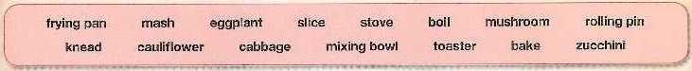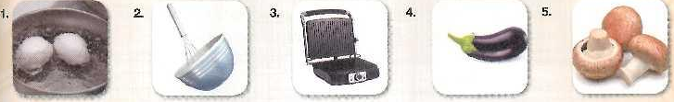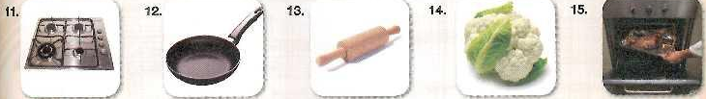
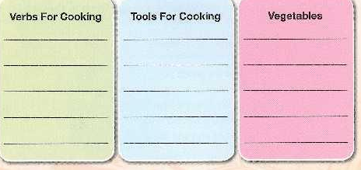
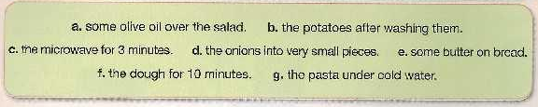
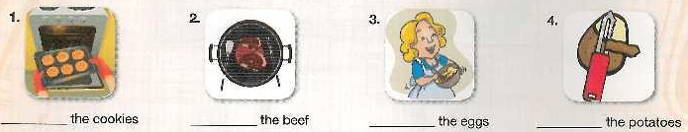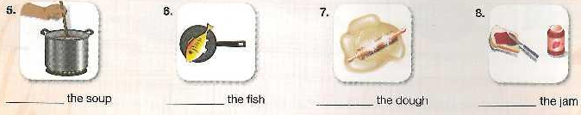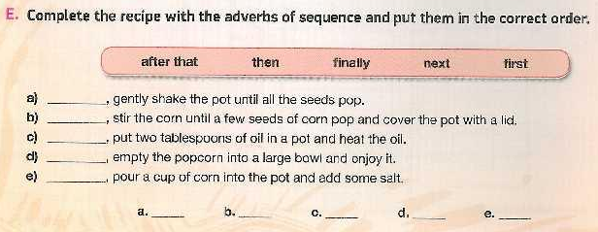
F
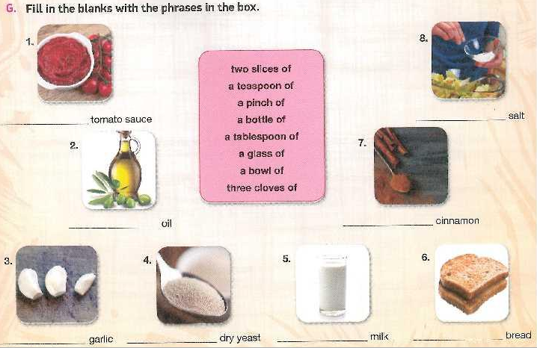
13.11.2017
UYGUNDUR
AYDIN DEMİRAL
OKUL MÜDÜRÜ

