 | MARK (NOT) | 2017-2018 EDUCATIONAL PERIOD |  |  | DATE (TARİH)
 |  | DADAY ANADOLU IMAM HATIP SECONDARY SCHOOL |  |  | 02/01/ 2018
 |  | ENGLISH LESSON | 1ST TERM | 3 ^{RD} EXAM
 |  | QUESTIONS | FOR GRADE 6TH |  | TUESDAY
 | NAME (AD)
 | SURNAME (SOYAD) |  |  |  | MEHMET
 | NUMBER (NO) |  |  |  | DEGERLI
1 | 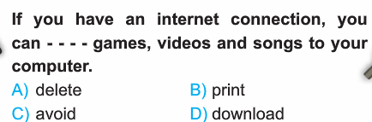  6 |  | 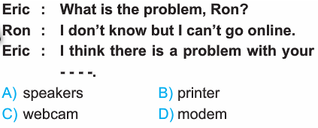
2 | 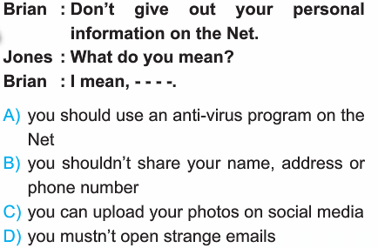  8  7 |  | 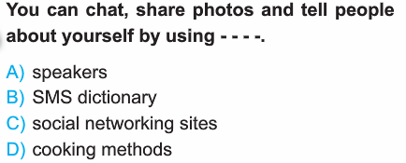
3 | 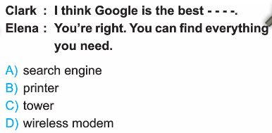 |  | 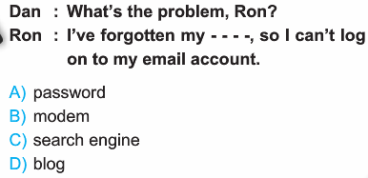
4 | 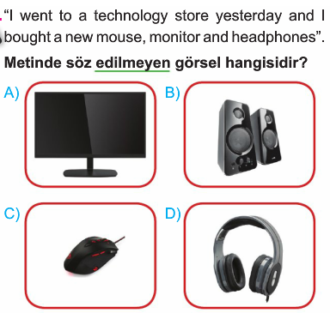  9 |  | 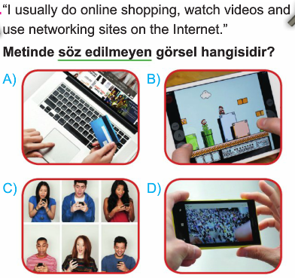
5 | 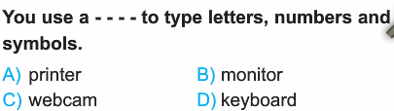  10 |  | 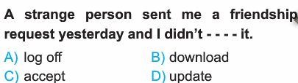
11 | 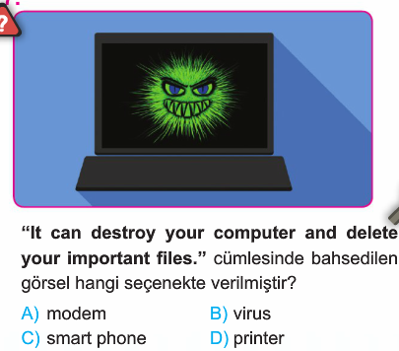  17 |  | 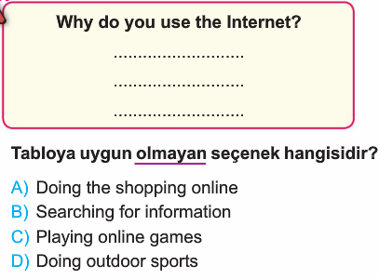
 | 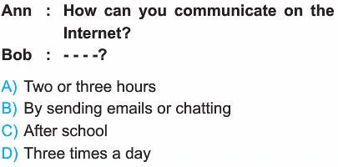 |  | 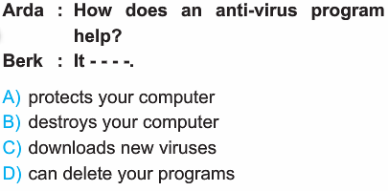
 | 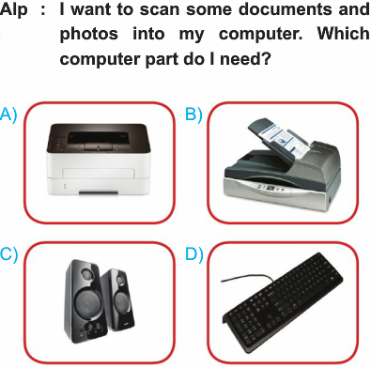  19 | 18. 19. 20. | 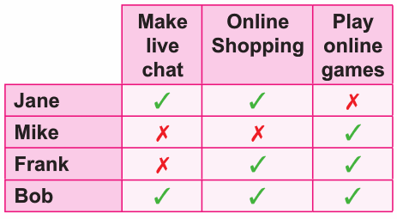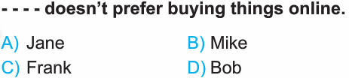  18
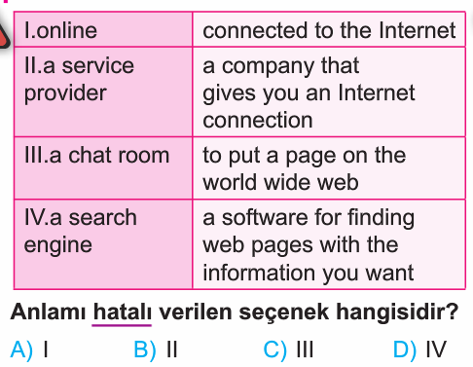
20
 |  |  | 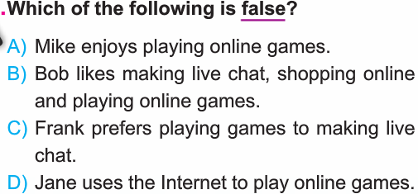
 | 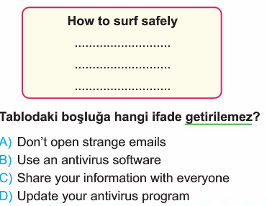 |  | 02.01.2018  Uygundur  AYDIN DEMİRAL  DADAY AİHL MÜDÜRÜ
16
15
14
13
12

