 | MARK (NOT) | 2017-2018 EDUCATIONAL PERIOD |  |  | DATE (TARİH)
 |  | DADAY IMAM HATIP SECONDARY SCHOOL |  |  | 16/10/ 2017
 |  | ENGLISH LESSON | 1ST TERM | 1 ^{ST} EXAM
 |  | QUESTIONS | FOR GRADE 8TH |  | ________________
 | NAME (AD)
 | SURNAME (SOYAD) |  |  |  | MEHMET
 | NUMBER (NO) |  |  |  | DEGERLI
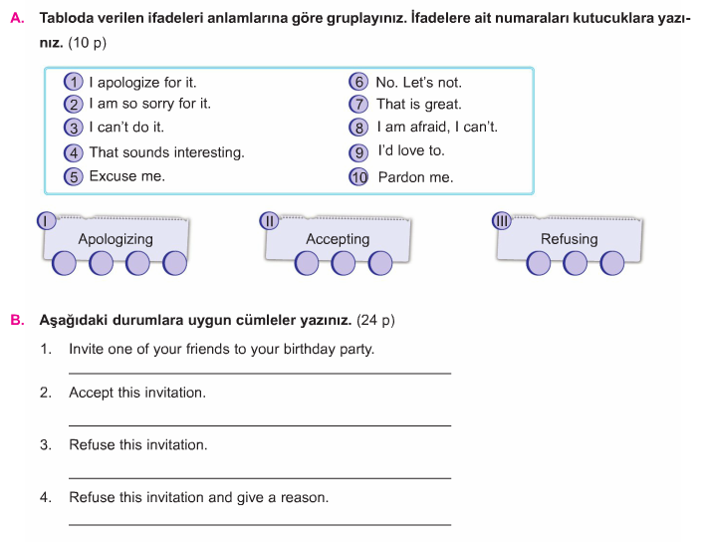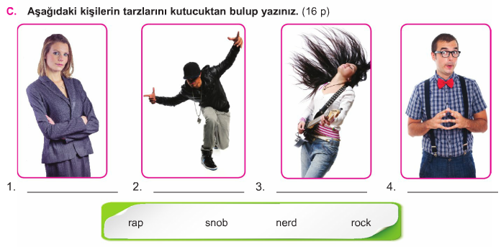

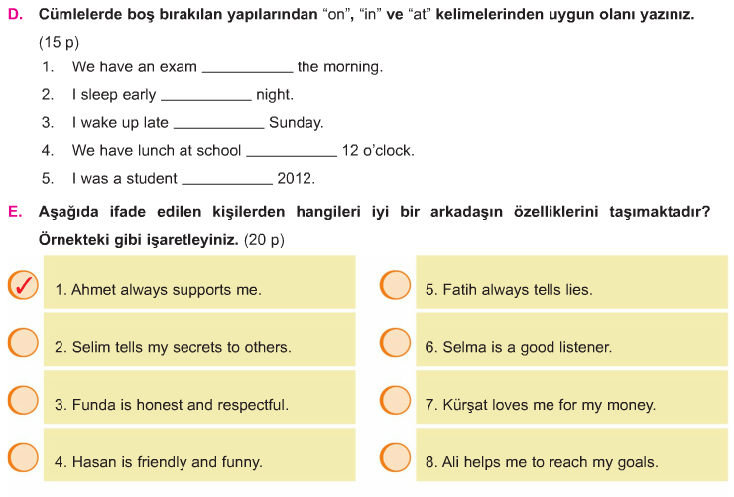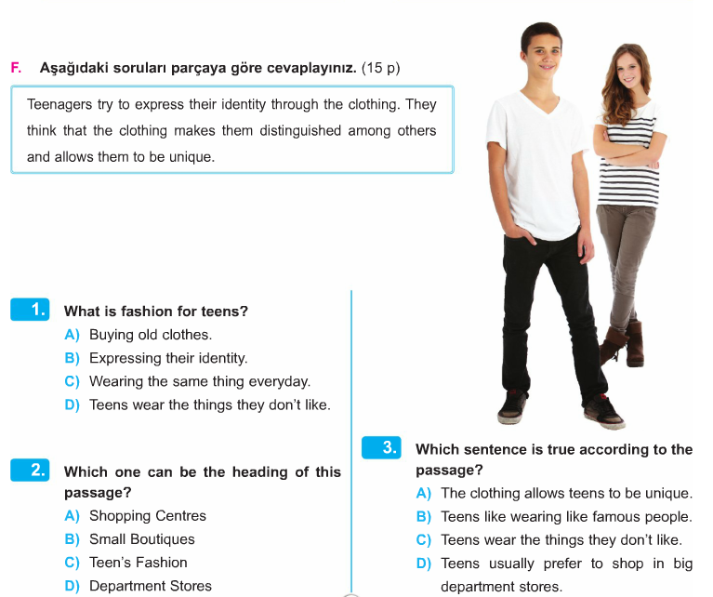
GOOD LUCK
MEHMET DEGERLI
ENGLISH TEACHER 16.10.2017
AYDIN DEMIRAL
AIHL MANAGER

