1.BÖLÜM (TABLOYA BAKARAK TABLONUN ALTINDAKİ CÜMLELERİ KİMLERİN SÖYLEDİĞİNİ BULMAYA ÇALIŞALIM. YALNIZ EN İYİ BİLDİĞİNİZ 5 TANESİNİ YAPALIM. 5X4=20
DADAY ANADOLU İMAM HATİP ORTAOKULU
2017-2018 EDUCATIONAL PERIOD ENGLISH LESSON GRADE 5 FIRST TERM SECOND EXAM QUESTIONS
NAME=___________________________SURNAME=________________________NUMBER=______
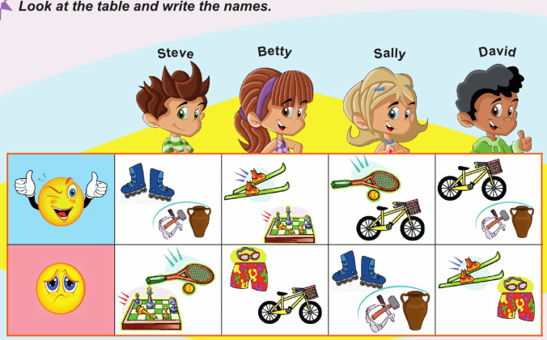
____________________________ 1. I can skate but I can’t play tennis.
____________________________ 2.I can’t swim but I can ride a bike.
____________________________ 3. I can play tennis but I can’t sculpt.
____________________________ 4. I can skii but I can’t swim.
____________________________ 5. I can do sculpting but I can’t play tennis.
____________________________ 6. I can’t skate but I can ride a bike.
____________________________ 7. I can play chess but I can’t ride a bike.
2.BÖLÜM (AŞAGIDA VERİLEN CÜMLELERİ KENDİLERİ İÇİN İKİYE AYRILMIŞ OLAN ALANA DOĞRU OLARAK YAZALIM. 10 TANESİNİ YAPALIM. 10X2=20
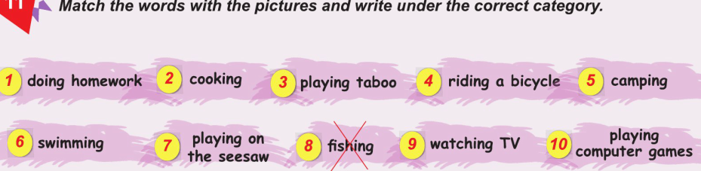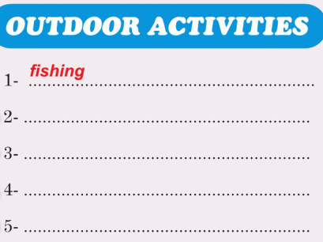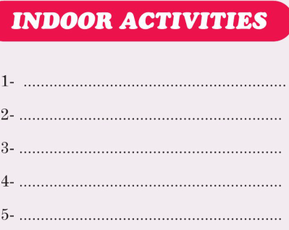

3.BÖLÜM (AŞAGIDA VERİLEN RESİMLERİN ALTINA can ya da can’t KULLANARAK ÖRNEKTE VERİLDİĞİ GİBİ RESİMDEKİ EYLEMİ ANLATAN CÜMLELER KURALAIM. 10 TANESİNİ YAPALIM. 10X2=20
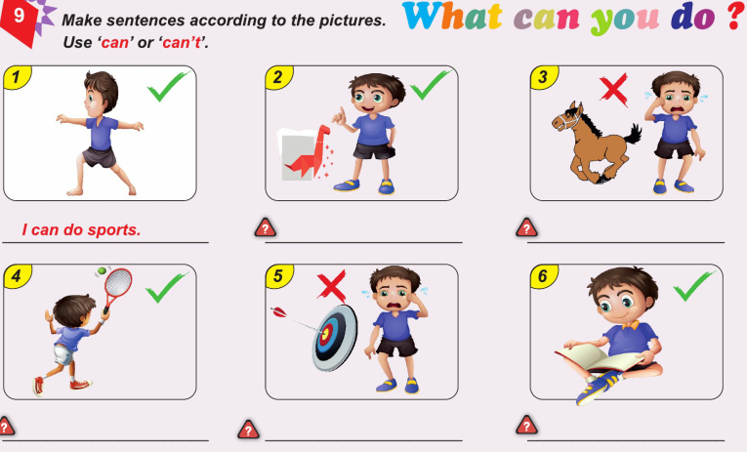
do sports do origami ride a horse
play tennis do archery read a book

play football go fishing/fish play chess

draw pictures/paint use/do the hulo hoop skate

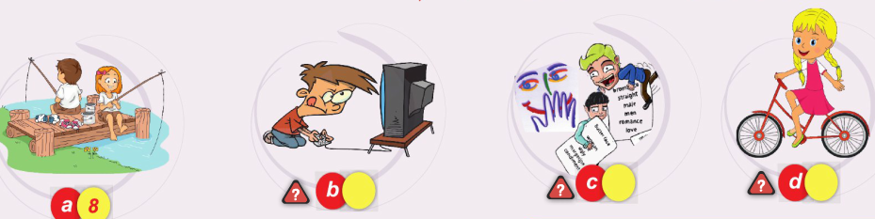
4.BÖLÜM (AŞAGIDA VERİLEN KELİMELERİ RESİMLERLE EŞLEŞTİRELİM. 10X2=20
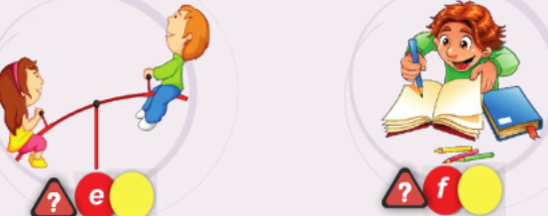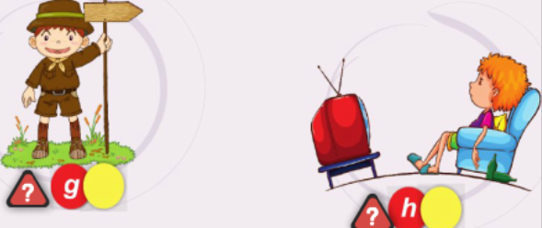

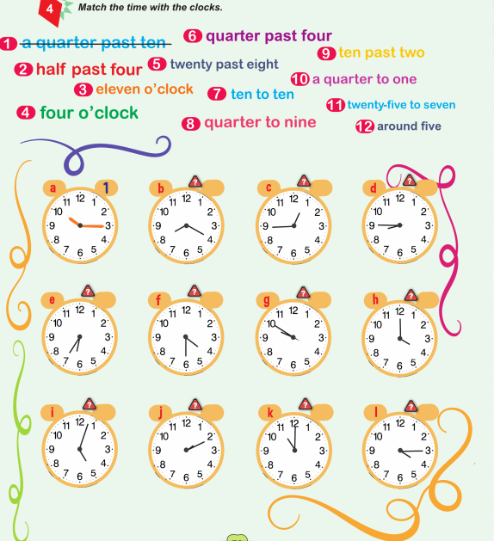
5.BÖLÜM (AŞAGIDA İNGİLİZCE OLARAK VERİLEN SAAT AÇIKLAMALARINI KENDİSİNİ ANLATAN RESİMLERİ İLE EŞLEŞTİRELİM. YALNIZ 10 TANE YAPALIM 10X2=20

a.10.15=It is _1_ b.08.20=It is _____ c.12.45=It is_____ d.08.45=It is______
e.06.35=It is____ f.04.30=It is _____ g.09.50=It is_____ h.04.00=It is______
i. 05.00=It is____ j.02.10=It is _____ k.11.00=It is_____ l.04.15=It is ______

02.01.2018
Uygundur

AYDIN DEMİRAL
DADAY AİHL MÜDÜRÜ

