 | MARK (NOT) | 2015-2016 EDUCATIONAL PERIOD |  |  | DATE (TARİH)
 |  | DADAY ANADOLU IMAM HATIP SECONDARY SCHOOL |  |  | 16/11/ 2017
 |  | ENGLISH LESSON | 1ST TERM | 1 ^{ST} EXAM
 |  | QUESTIONS | FOR GRADE 6TH |  | THURSDAY
 | NAME (AD)
 | SURNAME (SOYAD) |  |  |  | MEHMET
 | NUMBER (NO) |  |  |  | DEGERLI
SECTION 1 MATCH THEM RESİMLERLE İNGİLİZCELERİNİ EŞLEŞTİRELİM. 2X15=30
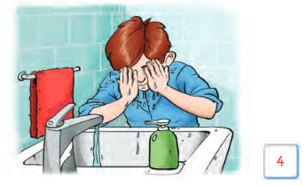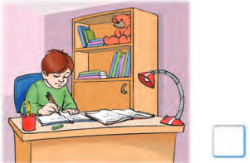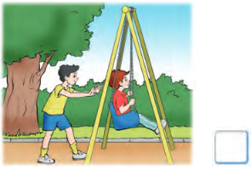
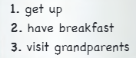

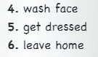

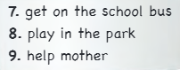

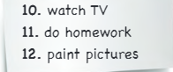

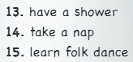
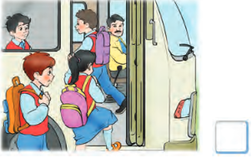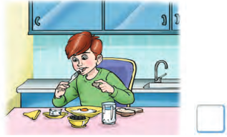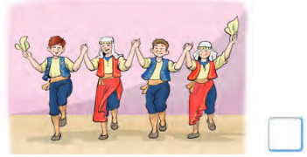
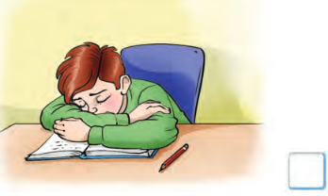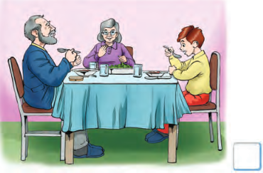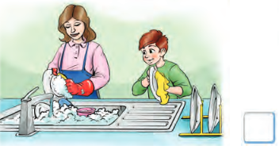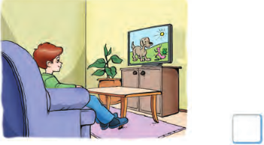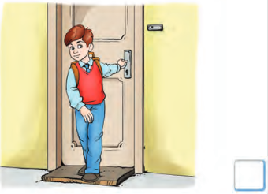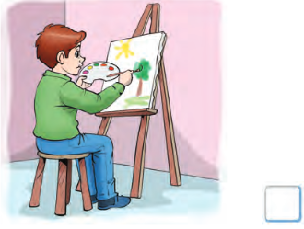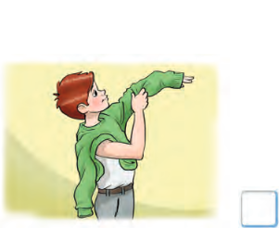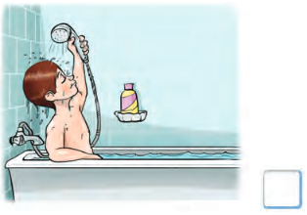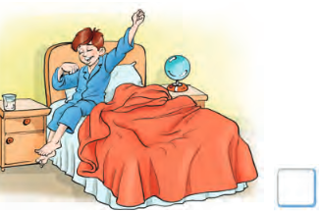
SECTION 2 COMPLETE THE BLANKS a little / a few 2x5=10
1.There is …………………………milk in the bottle.
2.There are ………………………….oranges in the basket,
3.There are ………………………….dogs in front of the car.
4.There are ………………………….pencils on the tables.
5.There is ……………………………water in the glass.
SECTION 3 Fill in the blanks with some or any SOME-ANY HER BİR SORU 3 PUAN 2X5=10
- There is ……………………..……..honey in the bottle.
- Are there………………………..….appes on the table?
- There aren’t …….…………..……..bananas on the table.
- There is ……………….……..coffee in the cup.
- Is there …………….……………..water in the glass?

BÖLÜM 4 MATCH THEM Saatler ile okunuşlarını eşleştiriniz. (5x2=10 puan)
____
____
____
____
____

SECTION 5 Fill in the blanks with how much / how many HER BİR SORU 5 PUAN 2x5=10
- ……………………………………………... bananas are there on the table?
- ………………………………..……………. apples are there in the basket?
- ………………………………………………coffee is there in the cup?
- ………………………………….……………milk is there in the bottle?
- ………………………..……………………..water is there in the glass?

SECTION 6 ANSWER THE QUESTIONS SORULARI CEVAPLAYINIZ HER BİR SORU 4 PUAN 5x5=20
1.How many days are there in a week? (seven days)
____________________________________________________________________________________________
2.How many weeks are there in a month? (four weeks)
____________________________________________________________________________________________3.How much sugar is there in the tea? (some)
____________________________________________________________________________________________
4.How many students are there in the park? (any)
____________________________________________________________________________________________5.How much honey is there in the jar? (any)
____________________________________________________________________________________________

BÖLÜM 7 MATCH THEM HER BİR SORU 3 PUAN 2x5=10
a) a glass of tea b) a cup of coffee c) a piece of cake d) a jar of honey e) a bottle of water
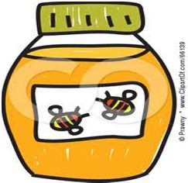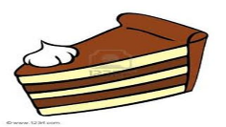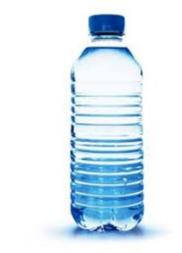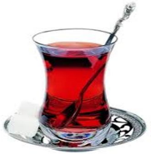
1 ______ 2______ 3________ 4________ 5___________

16.11.2017
AYDIN DEMİRAL
DADAY AİHL MÜDÜRÜ

